Shabbos Stories for
Yom tov pesach 5781
Volume 13, Issue 31 15-22 Nissan/ March 28-April 4 2021
Printed L’illuy nishmas Nechama bas R’ Noach, a”h

For a free subscription, please forward your request to keren18@juno.com

OPINION
Milk for Pesach
By David Olivestone

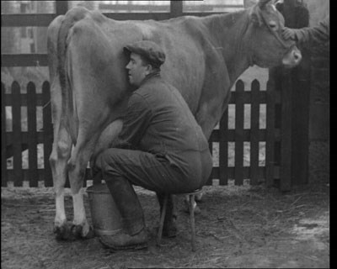
An English farmer milking a cow during the Second World War

Kosher for Passover food is now so abundant, thanks largely to OU Kosher, that we take it for granted. Of course, it wasn’t always so.
In England, where I grew up, the years of the Second World War (1939-1945) were a time of hardship and deprivation. Food, clothing and many other items were often in short supply and were rationed due to the war effort. Orthodox Jewish housewives would trade the bacon, ham and other treif foodstuff coupons in their ration books with their non-Jewish neighbors for coupons for butter, eggs and other items they could use.
In 1940 most young children were evacuated out of the larger cities when the German Blitz began. They were billeted with families in the safety of the countryside while bombs fell night after night on London and elsewhere, injuring and killing tens of thousands and destroying large swaths of homes and businesses.

Many Jewish Children Were
Placed in Non-Jewish Homes
Many Jewish children, often to their dismay, found themselves placed in non-Jewish homes. The foster parents, however well-meaning, had probably never met a Jew before, but at the very least usually realized that serving the children bacon for breakfast would not make them feel at home.
To its credit, the organized Jewish community realized that it was faced with an unprecedented, multi-faceted problem and struggled to meet the challenge, although understandably not always with great success. Besides trying to make kosher food supplies available wherever Jews were then to be found, great efforts were made to continue the children’s Jewish education, which was obviously vital given the circumstances in which many of them now lived.
Since they had three small sons aged eight, four and one (I was born later, toward the end of the war), my parents were evacuated with their family and were able to find a tiny house in Bovingdon, a small Hertfordshire village about thirty miles outside London.
They were probably the first—and last—Jews ever to live there. During the week, my father worked in London in a factory making parachutes for the Royal Air Force, often also serving as a nighttime fire warden, directing the fire brigade to where fires had broken out due to the bombings. He would come to Bovingdon for Shabbat, bringing whatever kosher food he could obtain.
Two frum teenage German refugee sisters were also living with my parents. They had come to England in the Kindertransport program and were placed in a Jewish group home. Since the home had no facilities for Pesach, the girls were sent to stay with a Jewish family for the week. But on arrival at their hosts, they very quickly realized that the home was not really kasher l’Pesach, and they telephoned the director of the group home asking to be placed elsewhere.
His initial reaction was that it would be impossible to find another host family so close to yom tov, whereupon the girls told him that he had better send two hearses right after Pesach as they would perish from starvation by that time. Somehow, my parents were contacted, and the girls ended up living with them for over two years.
My father was able to get matzot and some Pesachdik ingredients for my mother to cook with, but was faced with the challenge of how to obtain fresh milk. So he took a very tall glass vase and kashered it for Pesach. (This is not done much these days, but in Europe it was common for glassware to be kashered by soaking it in cold water for three days, changing the water every twenty-four hours.) He put the vase into my brother’s baby carriage and wheeled it off to a local farm.
So that he could be certain the milk would be kasher l’Pesach, he asked the farmer to milk directly from one of his cows into the vase. Whatever he might have thought of this request, the farmer was quite willing, but he had a problem. How would he know how much milk my father was taking and therefore how much to charge him? He proposed using his one-pint milk dipper to fill the vase with water, counting the number of pints it contained.
For my father, this raised a red flag. Even though he was quite aware that there was only a remote possibility that this procedure would make the vase—and the milk—chametzdik, he was taking no chances and had to come up with another plan. He suggested to the farmer that they first fill the vase with water, and then pour it from the vase into the dipper as many times as it would take. The problem was solved, and the milking commenced. When the vase was full my father paid the farmer and trundled it back home with its precious cargo, and the family had milk for yom tov.
But when Chol Hamo’ed came they needed more milk. Off went my father to the same farmer with the big vase in the carriage. Once again, he asked him to follow exactly the same procedure and to milk straight from the cow into the vase.
“Righto,” said the farmer in his agreeable manner, “but does it have to be the same cow?”
David Olivestone, a member of Jewish Action’s Editorial Committee and a frequent contributor to the magazine, lives in Jerusalem with his wife Ceil.

Reprinted from the Spring 2020 issue of the Jewish Action, a publication of the Orthodox Union.

Open Seders Will
Open Hearts
By Rabbi Yaakov Shapira

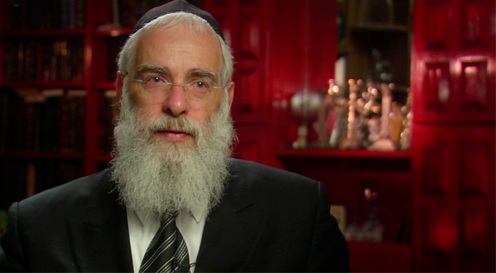
Rabbi Yaakov Shapira

My father, Rabbi Avraham Shapira, served as the Ashkenazi chief rabbi of Israel from 1983 until 1993, while Rabbi Mordechai Eliyahu served as the Sephardic chief rabbi. During their tenure they traveled to the United States three times for the purpose of visiting the central Jewish communities in America and getting to know their leaders. They met with the most highly regarded religious authorities and heads of yeshivot to discuss important matters of mutual concern.
I served as my father’s right-hand man and I was privileged to join him on these trips. This is how it happened that I was present each time – in 1983, 1986, and 1989 – when the two chief rabbis met with the Lubavitcher Rebbe.
Each meeting with the Rebbe lasted about three hours and involved a lively discussion which I found fascinating. The Rebbe spoke a very correct and clear Hebrew which he used during these meetings to accommodate Rabbi Eliyahu, who did not speak Yiddish.
Their conversations were far ranging – they debated a wide variety of questions in all realms of Torah law; they spoke about activities of the Israeli Rabbinate and the state of Yiddishkeit in Israel; and they discussed the prophecies concerning the coming of the Mashiach and the Final Redemption. They went from topic to topic, without pause, and their conversations were recorded, transcribed and later published.

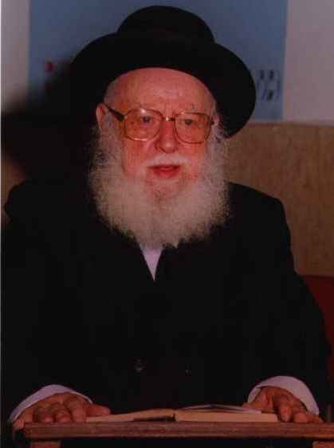
Rabbi Avraham Shapira, zt”l

During the first visit in 1983, the Rebbe asked the chief rabbis how they felt being outside of Israel. My father said that he had never left the Holy Land before, and that the time away was very difficult for him.
To bring him comfort, the Rebbe expounded on the Torah verse, “Jacob lifted his feet and went to the land of the people of the East,” pointing out that while Jacob’s departure from the Land of Israel was a spiritual descent, later it turned out that this descent was for the sake of a greater ascent. All Jacob’s sons – who would give rise to the Twelve Tribes of Israel – were born outside the Land. This is why the great 11th century Torah commentator, Rashi, reads the phrase “lifted his feet” as meaning Jacob “moved with ease” because G-d had promised to protect him and bring him back home. Indeed, Rashi goes so far as to say that “Jacob’s heart lifted his feet” – that is, his joy wasn’t just in his heart, but went down all the way to his feet. Based on this interpretation, the Rebbe concluded that even if one must leave Israel temporarily, one should be joyful, since a great ascent would come from this descent.

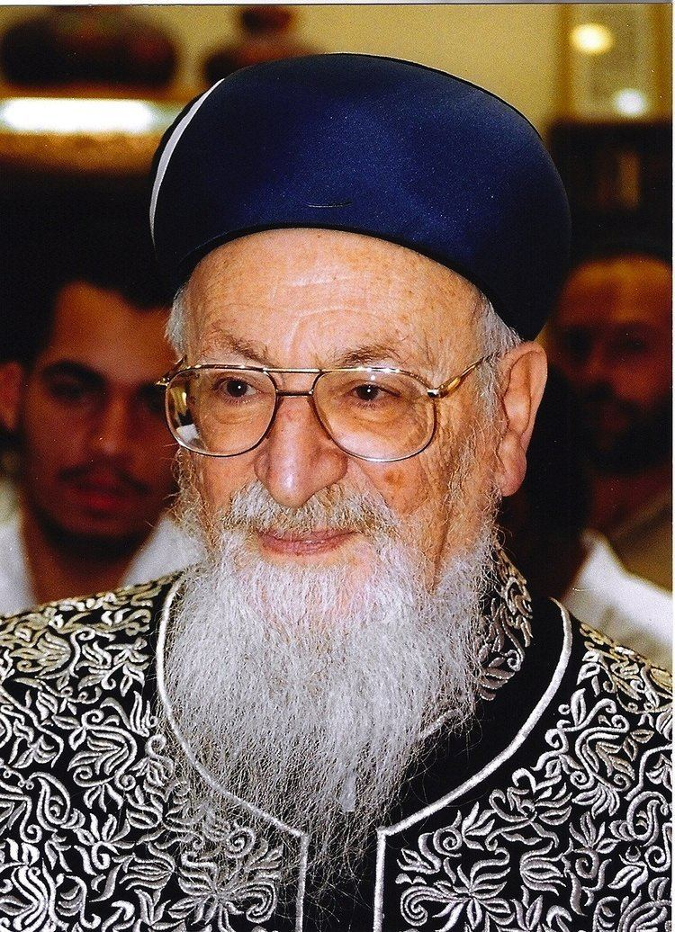
Rabbi Mordechai Eliyahu, zt”l

Later in the conversation, the Rebbe asked my father – who was a Kohen, a descendant of the priestly tribe – what he was doing about reciting the Birchat Kohanim, the Priestly Blessing. In Israel, the Kohanim bless the public every day during prayers, but in the Diaspora this is done only on Passover, Shavuot, Sukkot, and the High Holidays. My father responded that the Jewish Syrian community in the Diaspora practiced the Israeli custom, so he found a Syrian synagogue, Shaare Zion, where he would pray whenever possible. When he wasn’t able to go there, he very much missed giving the Priestly Blessing.
The Rebbe remarked that, although he had lived in New York for forty years, he didn’t know that they gave the Priestly Blessing at Shaare Zion every day, and he was glad to learn of this, adding: “When the Kohanim give this blessing, they are also blessed in all their affairs.”
This first meeting lasted about two hours and, at its conclusion, the Rebbe asked to speak to the two chief rabbis privately, without their entourage, apologizing to those present as he did so. The private meeting lasted another forty-five minutes, and then the Rebbe escorted the rabbis out until the entrance of the building.
Afterwards, I remember my father speaking of the Rebbe with great admiration and remarking how extremely well versed the Rebbe was with everything that was going on in Israel. As well, the Rebbe’s endeavors in the field of spreading Yiddishkeit had made an enormous impression on him, so much so that he declared: “To achieve these results, he must be able to produce electricity like a big generator or a power plant – a regular battery wouldn’t be enough.”
In subsequent meetings, I noticed that while the Rebbe and the chief rabbis spoke about Torah concepts, the Rebbe always found a way to direct the conversation toward practical applications, so that nothing would remain just talk, but be put to use out “in the field,” so to speak.

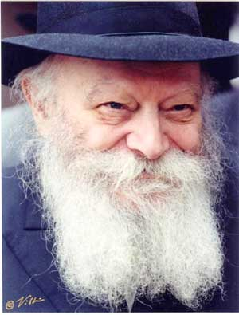
The Lubavitcher Rebbe, zt”l

For example, the second visit in 1986 took place close to Passover, which led to a lengthy discussion of the Pascal Offering. The Rebbe connected that to the Torah commandment, “And you shall tell your son…,” urging the chief rabbis to spur Israeli rabbis to hold open seders in order to ensure that all Jews who weren’t planning to make a seder would have a chance to participate.
My father responded that most Israelis, even those who are not religious, do hold family seders, to which the Rebbe replied, “Hopefully, that will indeed be the case this Passover, but if – Heaven forbid – it is not, I see no other way to fix it … From what I hear about Israel, there are many children who don’t participate in a seder.”
My father maintained that there were already public seders for those who have no place to go, but the Rebbe was not mollified.
“That is not enough,” he insisted, “because people are embarrassed to say they have no place to go. The solution I am proposing is that the local rabbi hold his own seder – with his students and his family – in the center of the city, inviting all the residents to join him. And then many people will come.”
The Rebbe devoted a great deal of time to explaining how it should work – how local rabbis should publicize these seders, making it clear that one and all are welcome, especially the children. “Whoever is interested should know that they can come and receive matzah and wine,” the Rebbe said, “without being required to pay anything and without being required to stay all the way to the end.”
The Rebbe acknowledged that such an initiative would cost money, and he offered to make a financial contribution, and even to persuade others to join in funding it.
He smiled as he said this, joking that every Jew is a natural businessman. “And the profit that I want to make from this business is that, as a result of these seders, people will get to know each other, and their children will get to know each other, and that, after Passover, they will continue to be drawn closer to Torah.”
The Rebbe was completely serious about it; he wasn’t just talking. Although the meeting ended at a late hour, we were surprised – as we left our hotel for prayers very early the next morning – to be greeted by a man who said, “I was sent by the Rebbe,” and who handed us a check, the Rebbe’s first contribution toward these open seders.
This was the Rebbe’s style – to get things done within hours. Our meeting ended shortly after midnight and only six hours later his commitment had already been fulfilled!

Yaakov Shapira
For the past thirteen years, Rabbi Yaakov Shapira has served as the Rosh Yeshivah of the Merkaz HaRav yeshivah in Jerusalem, and as a member of the Chief Rabbinate Council of Israel. He was interviewed in March of 2010.

Reprinted from the files of The JEM Foundation’s “Here’s My Story.”
The Rav’s Eight-Year-
Old Grandson

Moreinu HaRav [Gamliel Rabinowitz) shlita relates: In our house we are careful to follow the halachos to the letter. For example, we are told to check for chometz in holes and cracks, so we check everywhere, even the places that have already been cleaned are thoroughly checked. We do a true and basic bedikas chometz.
Although we are older and at our age it is hard to bend down, my solution is – grandchildren. Even now in the time of corona, my son and grandchildren have been living with me the whole time and these young grandchildren help me search in the places that are hard for me.
So I assigned an eight-year-old grandson for the bedikah and I explained to him that I am going to search places where he saw his grandmother and mother had already cleaned and mopped several times.
He asked why we had to search when it was so clean? I told him because Chazal told us to and we follow halacha without changing anything and if we do not find anything, we have still fulfilled the mitzvah.
The grandson understood and accepted it and we searched. When we reached our bedroom, I asked him to bend down and look under beds and see if there is chometz.
Suddenly, the grandson jumped up in joy and shouted: “I found, I found chometz!!!” He found a half-eaten wafer literally the size of a kezayis of chometz!!!
The grandson was excited and so was I and the rest of the family. He had asked and he was answered that even this room which is basically cleaned and even under the beds had been swept and still chometz was found under the bed which showed a young grandson how chometz can reach a room without intention.

Reprinted from the Parshas Emor 5780 email of Tiv Hakehila.

How a Billboard in Oklahoma Changed a Young Man’s Life
By Aharon Loschalk

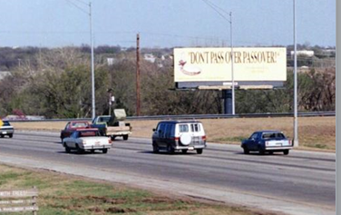
One college student's Jewish journey began in the early 1990s when he saw this unexpected billboard on a highway in the middle of Oklahoma.

Sometimes, all it takes is a billboard. In the middle of Oklahoma, no less.
Seth Feldman grew up in the Bayside neighborhood of Queens, N.Y., where, in his words, “everyone was Jewish.” In an environment like that, being Jewish was only natural, and young Feldman didn’t give it much thought.
Then he left home—first as a student at Northwestern University in Evanston, Ill., and then traveling throughout the country in the context of his budding television-production career. Suddenly, he was forced to reckon with his Judaism in an entirely different way. Over the decades, and with the help of rabbis and mentors in the various places he’s lived, Feldman grew closer to his roots. Today, he leads an observant Jewish life in Manalapan, N.J.
But on a visit to his alma mater late last year, a chance encounter at a Shabbat meal sparked a long-forgotten memory: The starting point of his Jewish journey when he was still a student at Northwestern in the early 1990s. It happened on a lonely highway in the middle of Oklahoma.
“As an alumnus, I’m still an avid fan of Northwestern’s football team,” Feldman tells Chabad.org. So in October 2019, he decided to catch a game, traveling with his son, Oren, from their New Jersey home to the Chicago area.
Mindful of the fact that he would be there for Shabbat, Feldman contacted Rabbi Mendy and Ariella Weg of Chabad-Lubavitch of Northwestern University to make arrangements. The Wegs were happy to help, and so there they were—the Weg family, Feldman and his son, and dozens of Jewish college students sitting together for Shabbat dinner that October night.
One brief enounter with a Jewish message can touch a person's heart and have an impact on generations. Here Feldman joins his daugher and her friends at a school party at the Hebrew Academy in Marlboro, N.J.
A Student’s Roadside Encounter With Judaism
Playing the typical game of Jewish geography, Feldman asked Weg where he was from. Atypical to the average Orthodox Jew, Weg responded that he was from Tulsa, Okla., where his parents, Rabbi Yehudah and Etel Weg, have served as Chabad emissaries since 1987.

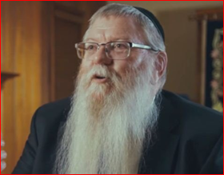
Rabbi Yehuda Weg

“That’s when I had the flashback,” says Feldman, one he shared with the rabbi and students.
“When I was a student at Northwestern University, I was on the rowing team. During Spring Break, we trained in warmer climates. One year, we trained down in Austin, Texas. It was a great opportunity for rowing, but it was horrible timing: I completely forgot it was Passover that week.”
Fortunately, on that first night of Passover, he was able to join a Seder at the University of Texas. But on the second night, he found himself on the team bus heading back to Chicago.
“I was feeling sad and angry with myself,” recalls Feldman.
And it was then, as the bus sped down the highway somewhere in Oklahoma, that he saw the sign that changed his life forever. As the ruminations of a passed-over Seder were festering in his mind, he looked up and saw a billboard emblazoned with the words, “Don’t Pass Over Passover,” together with a picture of matzah and wine.
“I was so upset with myself on that bus that night that my teammates noticed and asked me what was wrong,” he says. “When I saw that sign, I decided that I would never miss a Seder again. I felt that G-d was showing me a sign, and I wasn’t going to miss it.”
And, as they say, the rest is history.
Well, not quite: From Aruba to Honolulu—where he grew especially close to Chabad of Hawaii’s Rabbi Itchel Krasnjansky—to Los Angeles, New York, Portland, Hoboken, N.J., and finally Manalapan, Feldman embarked on a Jewish journey that changed his life.
And he’s actively shared that journey as well. Together with their local Chabad rabbi, Rabbi Levi Wolosow of Chabad of Western Monmouth County, Seth and his wife, Stacy, helped create an innovative High Holiday service dubbed “Project Rosh” that attracts more than 500 people annually. Feldman is the proud gabbai, and uses his marketing and narrative skills to spread the message near and far.
It’s a journey that, in his words, “is far from over.”
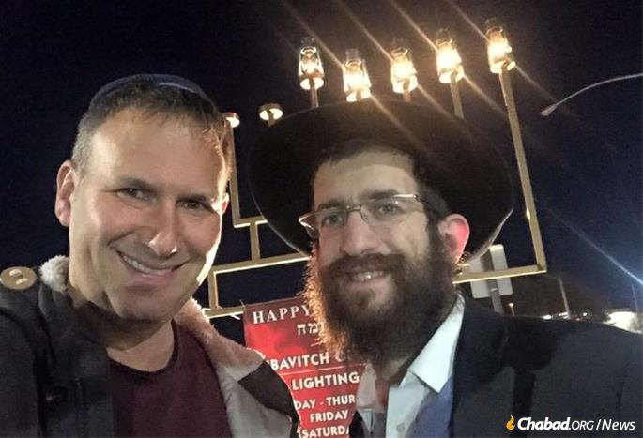
Seth Feldman, left, has developed an active and committed Jewish life. Here, he cebrated Chanukah with Rabbi Yosef Kramer of Chabad of Little Rock, Ark.

Where There’s Coke ...
So, who put up that sign?
Rabbi Yehudah Weg of Chabad of Tulsa, of course.
“The funny thing is that there was a good chance that the sign would never have happened,” the elder Weg remembers. “I never really thought of putting up billboards; it’s an expensive project. It so happened that for that year in the early ’90s, the Shluchim Office in New York arranged a nationwide billboard campaign, securing funding for the rental, design and all other logistics. All we rabbis had to do was pay for the printing and installation, which amounted to $400.”
But back then, even $400 wasn’t a small sum for Weg’s fledgling operation, and he hesitated.
What swayed him to go ahead?
When he personally visited the billboard site over the highway, he saw that the current advertiser was Coca-Cola. “If Coke is advertising here, there must be something to it,” he reasoned. He paid the money and before long, “Don’t Pass Over Passover” with Passover graphics blared across the Sooner State Highway.
For 30 years, Weg had no idea how impactful that sign turned out to be. It took decades, a football game, a Shabbat meal and his own son’s Chabad center in Chicago for him to find out.

Reprinted from the July 16, 2020 dispatch of Chabad.Org

Mesiras Nefesh of Keeping Pesach in a Siberian Prison
By Rabbi Tuvia Bolton

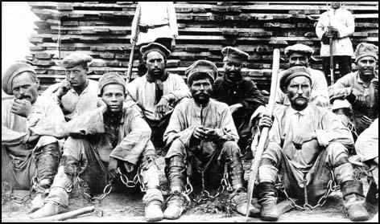
Siberian prison camp

The year was 1951; the war had ended in Europe but in Russia Josef Stalin, perhaps the most vicious mass murderer of all time, ruled the minds, souls and bodies of the U.S.S.R. through his propaganda, spies and secret police; the dreaded KGB.
Deep at night when people were in wrapped in cocoons of warm sleep oblivious of the fear and murder around them. the KGB would strike!
As they did to the Koblanov family.
The Koblanov family certainly took precautions to hide their religious practices the rest of the year but tonight was Passover, Holiday of Freedom. They were sitting, as Jews had done for over 3,300 years, around a simply 'decorated' Passover table celebrating the 'Holiday of Liberation.
This night they weren't afraid. But it wasn't easy to feel happy either.
Three of them were missing. Their father Reb Eliezer had been taken away by police in the middle of the night a few months earlier for 'anti-revolutionary activities'. Then their eldest sister Chaya (leaving behind her husband and a small baby) and finally their mother Elka were arrested weeks later and taken to the fearsome Spolerki Prison to await 'trial'. Only a miracle would bring them back but the Jews lived on miracles.

Hanging Over Their Heads Like a Sharp Sword
Who knows when the next arrest would occur? It was hanging over their heads like a sharp sword. But what good would being afraid or getting depressed do? Their only hope was G-d.
They remembered the words of the Lubavitcher Rebbe and his father before him: "Our enemies can control our bodies but nothing can control the Jewish soul."
And the words of Rabbi Akiva some 2,000 years earlier who defied the Roman prohibition of teaching Torah and when someone tried to talk him into compromising, he replied; 'Once a hungry fox tried to convince a fish to leave the stream saying, he'd be safer on dry land, 'Fool' replied the fish, 'If I'm not safe here where I'm supposed to be, for SURE I won't last in a place I'm not created for.' A Jew without Judaism is like a fish out of water!"
So the five that were left; two sisters Liba and Sterna, their younger 20 year old brother Kerpil. their older brother Mendel and his wife tried to be as happy as possible and even managed to sing a few songs of redemption at the Seder.
But a few hours after the Seder when the family was asleep it happened. The house shook, the windows rattled. The KGB broke in, took away Kerpil and a few hours later at the crack of dawn returned and took his two sisters. Then a month later Mendel was taken. Now the entire family of seven was gone.

They Almost Wishes That They Were Dead
A few months later the seven of them met again. But this time all in chains standing before the judge. At first, each was happy to see that the others were alive but when they heard their sentences, they almost wished they were dead.
Their father, Reb Eliezer, received ten years at hard labor in Siberia and the rest of the family got eight (very few people survived even the first year). Within the hour each was on a different train each headed for a different 'work' camp of the thousands scattered throughout vast Mother Russia.
Kerpil took it hard. He totally lacked the stamina necessary for the twelve-hour shifts, meager, bread diets and sub-zero weather. After a few months he was sure that he wouldn't be able to hold out.
But then two miracles occurred. The first; because he sat two months in medical school before he was arrested, he was unexpectedly appointed to the position of camp doctor which gave him slightly more freedom.
Then came the bigger miracle; one of the patients he treated turned out to be a Jew who, as a sign of gratitude, took a folded piece of newspaper from his pocket, carefully opened it on a table to reveal a piece of Matza (that he probably carried with him the entire year), broke off a small piece and put it in Kerpil's hand.

Several Months Before Passover
It was still several months before Passover but as soon as this small treasure was in his possession, he felt plugged in to a new source of life.
That Passover he found an empty room in the work camp, put the Matza before him, recited what he remembered of the Hagadda by heart, gave thanks for being a Jew, cried tears of joy and renewed his vow to always keep Passover no matter what!
But five years later it seemed he would have to break his vow. For four years he had survived hunger, fatigue, danger and cold and kept Passover religiously. But this year as the holiday approached, he felt very ill and every day weaker and colder until he was really worried.
For the rest of the year the bread kept him going and usually on Pesach he only ate vegetables that he cooked in a small pot he had secured. But this year it he was sure he wouldn't make it on such a meager diet. He felt as though he would pass out any moment or worse.
And to make matters worse he had to work. If he didn't do his job he would be demoted, punished, beaten, even killed! But somehow, he dragged himself to work every day for seven days and almost finished the holiday in one piece! But he was finished. Outside of Israel Passover is eight days and he knew he couldn’t last another day.

On the Last Day of Pesach
Then on the last day of Pesach a soldier came to him with an order to appear immediately before the dreaded chief doctor of the camp; a middle-aged woman with mean, narrow eyes who was known as an anti-Semite and a bloodthirsty sadist to boot.
Kerpil's knees knocked as he dragged himself to her office. If she decided to fire him he would have to return to hard labor ,.. which meant sure death. He stood before her, pale as a ghost, certain that this Passover would be his last. She gave him a startled look and said, "You don't look good. I think you have to get out of here." Kerpil couldn't believe his earsâ€¦ she was talking like a human being!
"You look terrible. Don't tell anyone I told you this" she continued, "But soon a group of officials will visit here to review all the prisoners. Since Stalin died (in 1953) things are changing. Just tell them that you regret your past deeds and I'm sure they will free you. You look terrible."
It seems that the poor diet of Passover was exactly what saved him!
A few months later the officials did arrive and over a half a year later just a week before the next Passover (!) Kerpil was freed!
But imagine his joy when he returned home to discover that just days before his entire family had unexplainably also been freed; all were alive and all miraculously had their sentences shortened in time to be home together for the holiday of Pesach!
That year at the Passover meal there were a lot of stories about self-sacrifice and G-d's miracles.

Reprinted from the Pesach 5780 email of Yeshiva Ohr Tmimim in Kfar Chabad, Israel.

An Amazing Story of Hesed

We keep seeing how much beautiful hessed and tzedaka is being done during this difficult time of Covid. There was a [Ashkenazi] woman in Lakewood who unfortunately lost her husband back in September. Pesach was approaching, and she was looking forward to hosting her children and grandchildren for the Sedarim and meals. When Coronavirus struck, she was devastated. This almanah would be alone for the entire holiday.
The woman has a next door neighbor whose window is directly across from hers. The neighbor [who was Sephardi] called her up and said, “I don’t want you to be alone during the holiday. I’m going to push my dining room table up against the window, and you will also sit by yours, and we’ll do the Seders together.” She gladly accepted.
After Pesach ended, the woman’s son called her and asked how her holiday was. She said, “It was really great actually!”
The son was surprised and asked why.
She answered, “My neighbors sat by their window so I could participate in their Seder. You wouldn’t believe it. They read all the parts of the Haggadah and all of the songs in your father’s tunes. The same way Dad always used to conduct our Seder was the way the neighbors also did! It made me feel so good and not like a lonely widow. It was the best possible Seder under the circumstances!”
Little did she know, before Pesach, the [Sefardi] neighbor had called the son. He said, “I want to make your mother feel special. I want to have her do the Seders with us by the window and for her to be as comfortable as possible. Can you please teach me the exact [Ashkenazi] tunes for how your father used to read the Haggadah?”
After he learned, he sat down with his wife and children, and they practiced over and over. They wanted to sing exactly how this almanah was accustomed in order to make her feel comfortable and less alone!
Something so simple yet so thoughtful could go a really long way. These ordinary people did an extraordinary thing to make an almanah feel so special. Hessed like this is what will bring Mashiah swiftly in our days!! Amen!
May we all appreciate the blessings we get from the kohanim. May we also learn the importance of not speaking lashon harah even when it’s seemingly innocent. May we all learn from the amazing story that [Sephardi] family did for the [Ashkenazi] Almamah for her Pesach Sedar that she was forced to spend without her family. Lastly, may we remember to use the tools gifted to us as a means to always serve Hashem.

Reprinted from the Parashat Beha’aloteha 5780 email from Rabbi Amram Sananes as written by Jack E. Rahmey.

